# WORDLE PLAYER PROJECT

Bohan Feng (NUID 001564249)

Olasunkanmi Olayinka (NUID 001512266)

https://github.com/fengb3/INFO6205_final_project

## Table of Contents

* Introduction about the topic
* Aim of the project
* Steps to implement solution
* Build steps and requirements
* Complete project details and its functionalities
* Application images
* Analysis
* Unit test
* Conclusion
* Reference

### **Introduction about the topic:**

Wordle is web-base word game in which the goal is to guess a five-letter word, and you are given 6 different chances to guess the word, each time you make a guess you get some information about how close the word you guessed is close to the actual word. The letters are color coded; grey means the letter doesn’t exist in the word, yellow mean the letter exist but it’s in the wrong position and green means the letter exist and is in the right position.

This project introduces a software that takes the word guess with each letter’s color code and calculate the next best possible guess word using information theory.

### **Aim of the project:**

Create a wordle player that will choose the best words for any given move, according to the principles of entropy, here by optimizing the number of chances it takes you to guess the correct word

### **Steps to implement solution:**

* Compare each pair of words to get a pattern matrix
  + We use a look up for every time we compare 2 words to speed up the process
* Calculate the expected amount of information we can get from each word in a word list
  + If we enter a word to wordle game, the pattern we get can help us exclude half of the words, we can define that we reduce 1 bits of information. For a possibility of a pattern , we need inputs, where satisfy . After simplifying the formula, we can get where is the amount of information provided by a pattern for a word.
  + The entropy is the expected Information of a word, so we loop though all the pattern for each word in legitimate word list to get the probability of matching another word for a pattern which is
  + Then the amount of information provided by each pattern is weighted to obtain the information entropy of a single word.
  + So, the formula to calculate the entropy of a word is
* Get the word frequency to know how likely a word is to be a common word
  + We use a data set to get the frequency of a word in English language
  + Based on the data set, we sort all the 5 letters words by their frequency
  + The use the sigmoid function to give each word a probability to be common word
  + The sigmoid function gives each word a probability that almost 0 or 1. So it is easier to identify if a word is a common word
* Combine entropy and probability to give each word a rank as recommendation
  + We basically add 2 values
* Use two steps to get best beginner words
  + For each opening word, we try to find the word with the largest amount of information in the list of valid words generated after they satisfy a certain pattern as the best choice for the second step.
  + Then add the information entropy of the first word and the best second word to get the information entropy of the 2 steps entropy for each opening word.
  + Then we use each word in words list as the answer to test the top 50 entropy opening word to see which opening gives the best score.

### **Build steps and requirements:**

You will need JDK 11 or greater and IntelliJ idea for build the application

1. Download and unzip project into directory of choice
2. Setup project SDK in IntelliJ with Java 11 or greater
3. Run the Main.java file   
   Note: this will take time (15 – 40 mins) running the first time to create entropy_map and pattern_matrix, to reduce time you can add files [entropy_map.txt and pattern_matrix.txt](https://drive.google.com/drive/folders/1ffIKy1CKfYC06kVAohdaFUFc2TniVG4j?usp=sharing) (this couldn’t me pushed to GitHub because of file size limitation) to the data directory

### **Complete project details and its functionalities:**

* Start the application by running Main.java  
  The Wordle application UI should pop up (you can play regular wordle with this)
* Click on Wordle Hacker button to open the Wordle Player (Hacker) UI  
  The Hacker UI should pop up showing Top pick, Entropy, and the Probability
* Play the Wordle application and the Hacker UI is auto populated showing next best possible words sorted with respect to probability.
* You can manually populate the Hacker app with your guess words and select the appropriate color, if you are playing wordle on a different platform or application
* You can run a Benchmark by clicking the benchmark button  
  This will run a test on 2309 guess words and returns the average number of chances it takes the Wordle Hacker to get the guess word. It logs how many tries it takes for each guess word on the console and writes the average number of chances into a file data/benchmark_$dateTime.txt

### **A Simple run of the application**

There are two windows in this application.

Each window can work separately or together, so the user can use the hacker to play with the real wordle game. when both of window are opened, the Hacker window will its statics based on the Wordle window.

#### Wordle app:

门上的瓷砖

Wordle application is simply wordle game that allow user to play multiply times.

**Submit** button will check the word's pattern between and move on the the next try.

**Reset** button will restart the game and set the answer to a new random word

**Wordle Hacker** button will open a new window named Hacker

#### Hacker app:

Hacker application displays statics of the wordle game

There is a table at the right side of the Hacker window, which displays the entropy and probability to be a common word in legitimate word list.

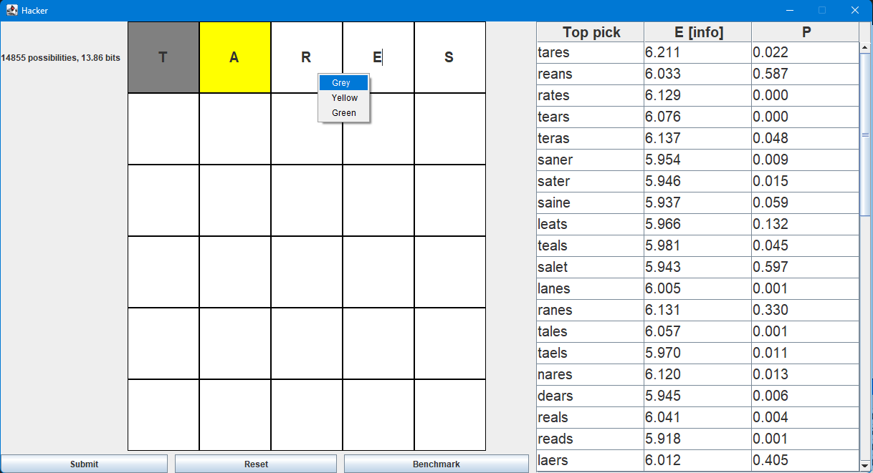

Right click the input box in wordle grid will pop up a menu, that allows the user to set the pattern of each guess

once a valid pattern is set to a word, clicking the submit button will update the legitimate word list and sort them by its entropy.

after each submission, the hacker will display how much word in the legitimate words, and the remaining information in terms of bits at the left of the wordle grid. Also, it displays how much information reduced after each try.

You can open the real wordle game, choose a guess from the legitimate word list, and set the pattern responded by the real wordle, to get recommendation for next try.

#### Wordle and Hacker work together

手机屏幕截图

Steps on playing this game when using Wordle and Hacker

1. enter a word to the Wordle application and click the submit button

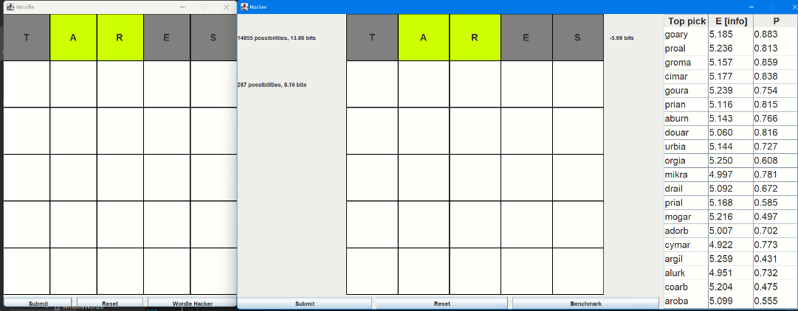

1. The wordle grid on both wordle window and hacker will set to pattern by comparing the wordle answer. Also, the list of legitimate will be updated.

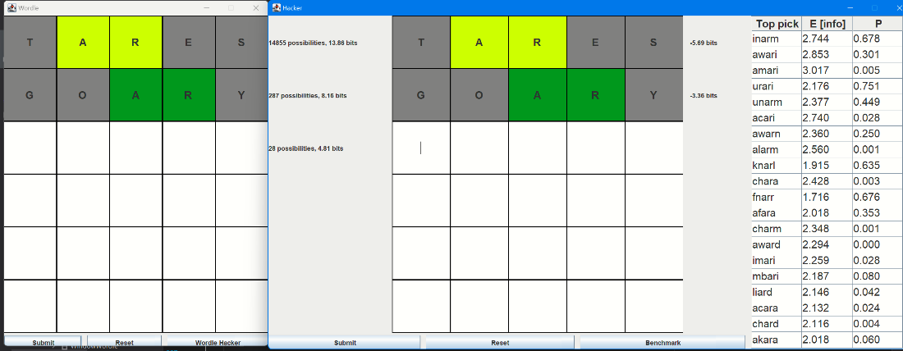

3. choose one of the words from Hacker's word list and type into the Wordle window. Then press submit in wordle window to get the pattern and updated word list.

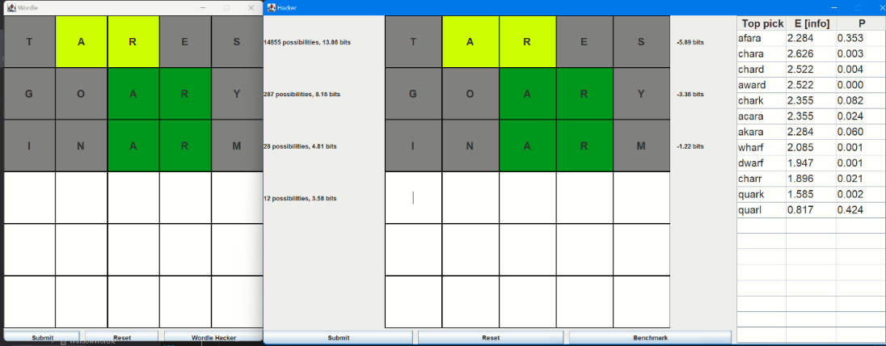

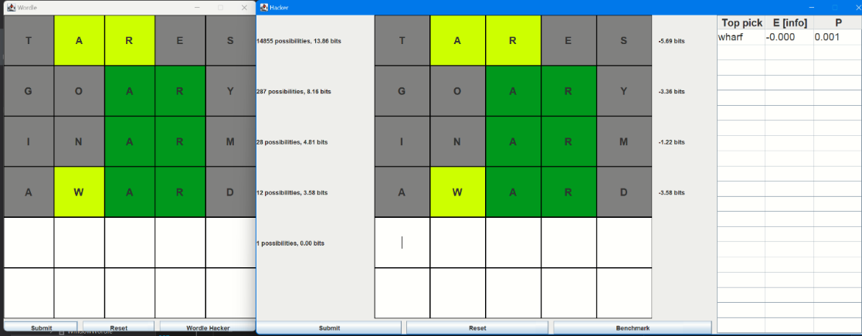

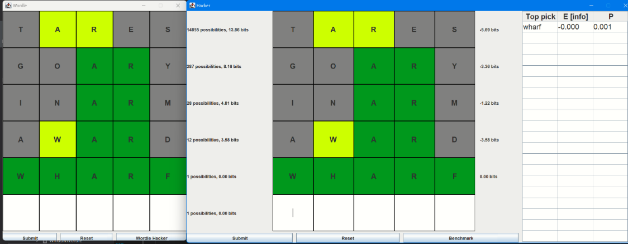

1. Keep trying words to get all green pattern.

Benchmarking screen shots:

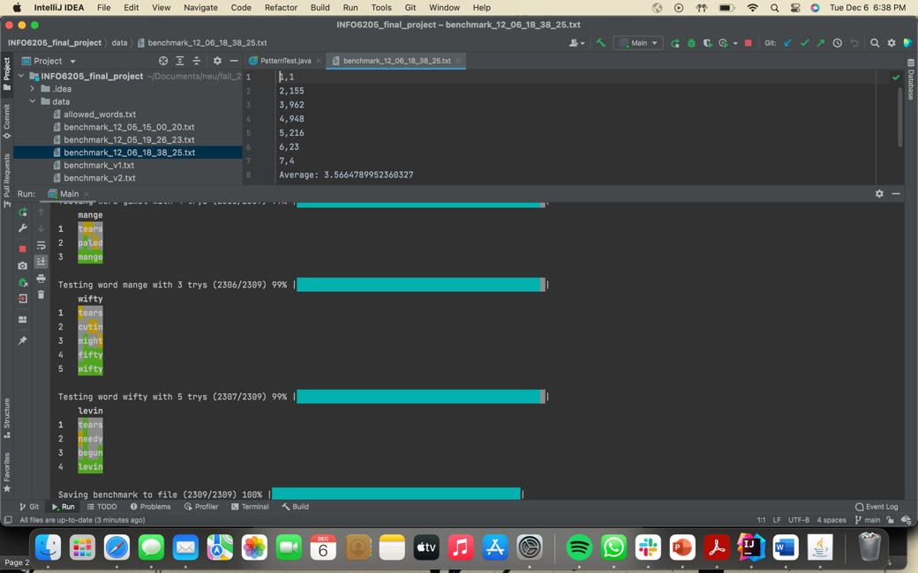

#### Entropy table screen shot:

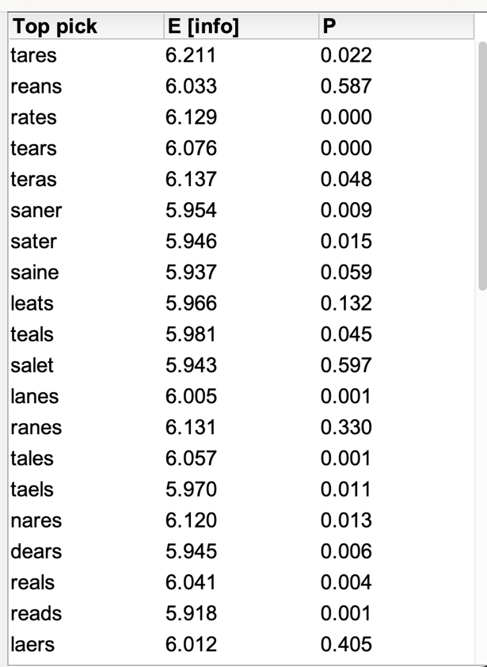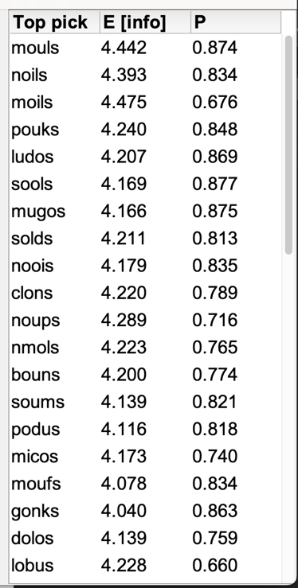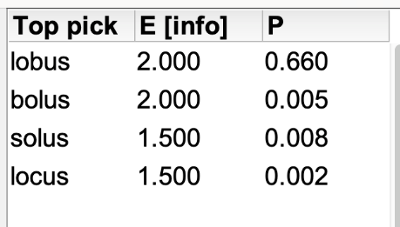

Move logs:

### **Unit test:**

### **Analysis of Time Complexity for Calculating a word’s Entropy:**

We define fine that is the number of letters in each word and is the number of words in legitimate word list. There are 3 different statuses for each letter in a pattern. So totally there are different patterns. To comparing each 2 words, we need loop though all the letters for times to get their pattern. So, the time complexity of getting entropy of a word in a legitimate word list is .

If we are not looping all the possible pattern, we just check the words and record the number of pattern occurrence. The time complexity will be the which Is the time to compare words times number of words.

### **Conclusion:**

Looping though all the words as the answer, we get the average number of tries used by the algorithm to give the answer.

In fact, after introducing the possibility of whether it is a commonly used word, the performance of the algorithm has decreased. This is different from the conclusion in the video. This may be because I used all possible 5 letters words list instead of the real wordle word list.

Our algorithm also calculates the maximum entropy in two steps to find the best starting word.

In the above figure, we can know that the opening word “tares” can make the operator find the answer in about 3.57 steps. This means, using our wordle hacker and start with “tares”, we can find the answer in 3 or 4 steps.

### **Reference**:

* English word frequency data set:

<https://www.kaggle.com/datasets/rtatman/english-word-frequency?resource=download>

* Wordle word list:

https://github.com/tabatkins/wordle-list

* <https://www.youtube.com/watch?v=v68zYyaEmEA%20%E2%80%A2%20>
* <https://www.youtube.com/watch?v=fRed0Xmc2Wg>